Name:
Period
Date:
Reading and Listening Actively

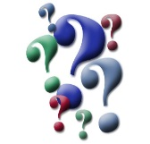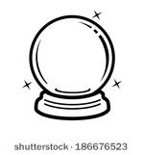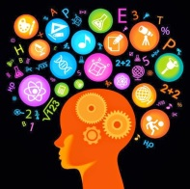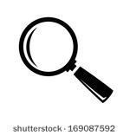
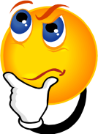
Reading is an active, not passive activity. While your body may not be active, your mind is, or should be, questioning, predicting, connecting, inferring, evaluating, and visualizing. Very often, we use these strategies while we read and we don’t even know we’re doing it. To become stronger readers, and thus, thinkers, practice focusing on these strategies while you read the assigned short story, and use them to answer the question on the back.
Directions:
1. Note on the story where you find yourself questioning, predicting, connecting, inferring, evaluating and/or visualizing.
2. Then, on the back of this paper, choose two of the reading strategies you used as you were reading, and then explain in the boxes how you used the strategy. For example, if you inferred, where in the story did you infer and what did you infer? If you connected, where in the story was the connection and what was the connection?
- Question: Question what happens and why. Search for reasons behind events and characters’ feelings and actions.
- Predict: Try to figure out what will happen next and the story might end. Read on to see how accurate you are.
- Connect: Connect personally with what you’re reading by finding similarities between the story and your experiences, knowledge, etc.
- Infer: Come to a reasonable conclusion based on the information you have in front of you, what you know.
- Evaluate: Form opinions about what you’ve read, both while reading and after. Develop ideas about characters and/or events.
- Visualize: Picture characters, events, and setting, paying attention to the images that form in your mind.
Strategy Choice #1_____________________________
Where did you use the strategy?

How did you use the strategy?

Strategy Choice #2____________________________
Where did you use the strategy?

How did you use the strategy?

3. Using the reading strategies, (especially inferring), determine what happens at the end of the story. What is the final twist or surprise at the end? In other words, why is the story ironic?
________________________________________________________________________________________________________________________________________________________________________________________________________________________________________________________________________________________________________________________

