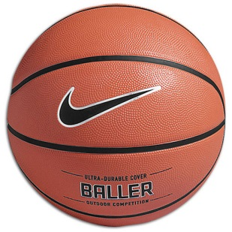 Name:
Period:
Date:
After reading the short story, “Slam Dunk”, answer the following questions. Use your glossary and notes from class for help with terms or concepts.
1. Summarize the plot of the story in a few sentences.

2. What is the conflict between the narrator and his brother?

3. What is the conflict between the narrator and his father?

4. What is the narrator’s internal conflict?

--over--
5. Who is the protagonist in the story?

6. Who is the antagonist in the story?

7.Infer: Explain the father’s reaction when the narrator pushes his brother’s head into the mashed potatoes. Infer what the father is feeling. How do you know?

8. Evaluate: What do you think of the way the narrator took care of the conflict with his brother? Why?

