“The Diary of Anne Frank”
Essay
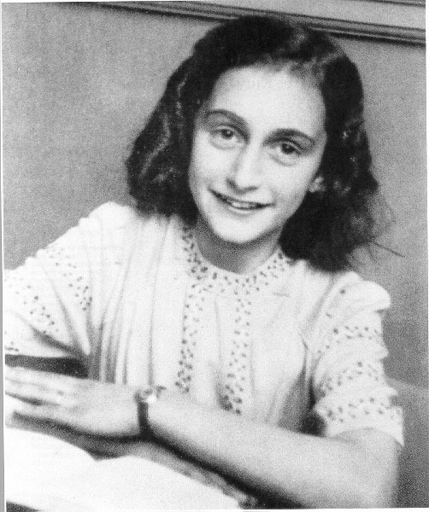

The play, The Diary of Anne Frank, is about a motivated, intelligent teenager who grows up in an extremely difficult environment. Freedom and life were at risk every minute of every day. Even in these circumstances, however, the protagonist, Anne, conveys a sense of courage and hope in her thoughts, words and actions.
In a well-developed essay, discuss how the reader sees both courage and hope through Anne and what she thinks, says and does.
There are sheets/organizers attached to help you brainstorm and organize your essay. Your final essay should be typed and passed in to me or submitted through Google Classroom. No handwritten essays will be accepted. The font should be 12 point, Times New Roman and double spaced.

The essay is due on _______________________________________

Use this space to BRAINSTORM ways COURAGE AND HOPE were expressed. (Think about messages the reader learns—when are these learned? What is happening in the play?)

Answer the question with your argument (this will be your THESIS). Be sure to include title and author(s).

Brainstorm possible ideas for body paragraphs.

List the topics for your body paragraphs (your examples you are going to be writing about in your body paragraphs).

