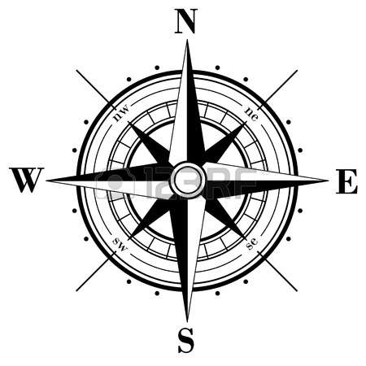
Soldier Island Map Activity
And Then There Were None by Agatha Christie
Task: In groups of 2-3, or individually, create a map of Soldier Island. The island, all locations on the island, the layout of the house, and important events and items to the story must be present on the map and labeled. The map should be large enough to fit all pertinent information clearly. This project must be IN COLOR (no pencil).
Locations: While developing the basic layout of your map, ensure the following locations are present (check them off as they are included):
Location | Done | Notes
1. Sticklehaven
2. The cliffs
3. The mansion
4. The wash house
5. The first floor layout of the mansion
6. The second floor layout of the mansion

Events/Items: While developing the basic layout of the map, ensure the following events/items are present:
Event | Done | Notes
7. The arrival (with boat)
8. The gramophone announcement (with gramophone)
9. Each murder—YOU MUST INCLUDE a SYMBOL that represents the character OR how they died (your choice, but must make sense).

Event | Done | Notes
10. The heliograph signal (with mirror)
11. “Ten Little Soldiers/Indians” poem
12. The manuscript (bottle at sea, maybe?)
13. Any other events/items/places that you think will enhance the look of the overall map/island
Text Evidence: While developing the basic layout of your map, ensure the following text evidence is present. This evidence should be cleanly and clearly presented (preferably typed):
14. At least one significant quote for one place (location). Fully explain who is speaking, to whom, when, and why it is significant/important.
Quote: page:_________ : ___________________________________________________________
________________________________________________________________________________
Speaker and “listener”: ____________________________________________________________
Significance: _____________________________________________________________________
________________________________________________________________________________
15. At least one significant quote for one item. Fully explain what is important about the quote and the item.
Quote: page:_________ : ___________________________________________________________
________________________________________________________________________________
Significance: _____________________________________________________________________
________________________________________________________________________________
16. At least one significant quote for one event. Fully explain why the quote and the event are important.
Quote: page:_________ : ___________________________________________________________
________________________________________________________________________________
Significance: _____________________________________________________________________
________________________________________________________________________________
This assignment is the unit assessment and will be worth 80 points.

